Applying Number Systems & Logic in Programming
. Connecting Number Systems to Programming: The "Number Conversion - Questions" document includes Exercise 9: "Write a program that receives a binary number as a string of zeros and ones and outputs the same number in decimal."
- Task: Write a Python program that implements this. The program should ask the user for a binary string (e.g., "1101") and then print the decimal equivalent (e.g., 13).
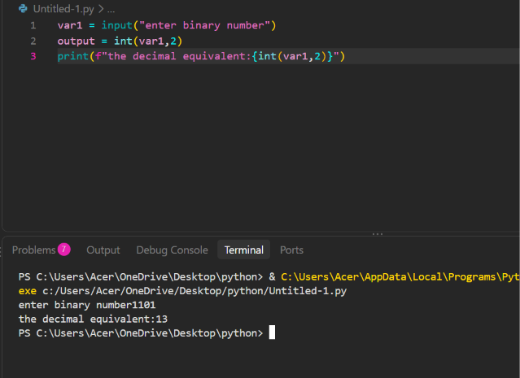
- Analysis: Explain how your program uses the algorithm of multiplying each bit by its corresponding power of 2 and summing the results. How would you modify your program to handle hexadecimal input as well? (Hint: You would need to multiply each digit by powers of 16 instead, and handle letters A-F). What is the significance of the "bank records" problem in Exercise 8? (Answer: The bank uses base 13).
The program converts binary number into decimal by using the powers of 2. Each bit is multiplied by its power of 2 and then all the results are added at last.
For example:1101
= 1*2^3+1*2^2+0*2^1+1*2^0
=8+4+0+1
=13
For the conversion of hexadecimal, the program uses the powers of 16. Each bit is multiplied by 16 for conversion. Then it also needs to convert the letters from A to F into their decimal values. For example, A = 10, B = 11, C = 12
The bank records problem is pivotal because it gives an example of using a different number system in a veridical situation. alternatively of using the regular base 10 system, the bank uses base 13. This means the place values are based on powers of 13. It helps show that different number systems can be useful for different types of problems.
3. Logic Gates in a Programming Context: The "Logic Gates - Practical(2)" document asks you to implement circuits and find truth tables.
- Task: Write a Python function called AND_gate(a, b) that takes two boolean inputs and returns the result of an AND operation. Then write functions for OR_gate(a, b) and NOT_gate(a).
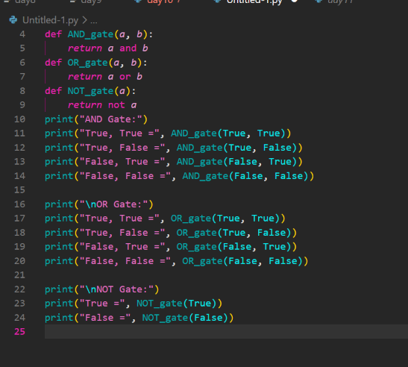
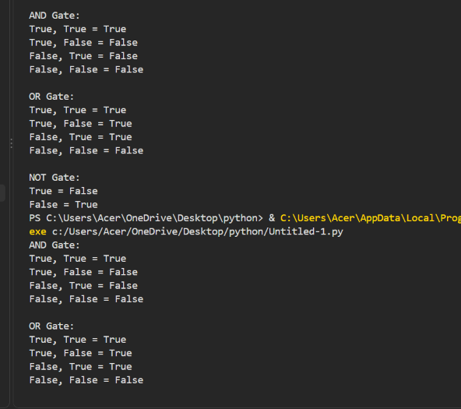

- Analysis: Test your functions with all possible input combinations (True/True, True/False, False/True, False/False). Compare your results to the truth tables in the "Logic Gates - Practical(2)" document. How do these simple functions relate to the complex logic circuits in a CPU? How does Python's built-in and, or, and not operators compare to your custom functions?
I tested the AND, OR, and NOT functions with different combinations of True and False. The results are the same as the standard truth tables for these logic gates.
The AND gate gives True only when both inputs are True. The OR gate gives True when at least one input is True. The NOT gate changes the value to its opposite, so True becomes False and False becomes True.
These simple functions are connected to the complex circuits inside a CPU. A CPU contains many electronic logic gates that work together to process information and perform operations. Although one gate can only perform a simple operation, many gates can be combined to create more complex circuits for calculations, comparisons, and decision-making.
Python already has the built-in operators and, or, and not. My custom functions use these operators, so they produce the same results. For example, AND_gate(True, False) gives the same result as True and False. The custom functions mainly make the idea of logic gates easier to understand and show how Boolean logic can be represented in a program.

2. Boolean Logic in JavaScript: The "Javascript1" presentation introduces conditions using if, else if, and else, along with logical operators (&&, ||, !).
- Task: Write a JavaScript program that simulates a simple login system. The program should have a predefined username and password. It should ask the user to enter their username and password, then use conditional statements with logical operators to check if the credentials match. Print a success or failure message accordingly.
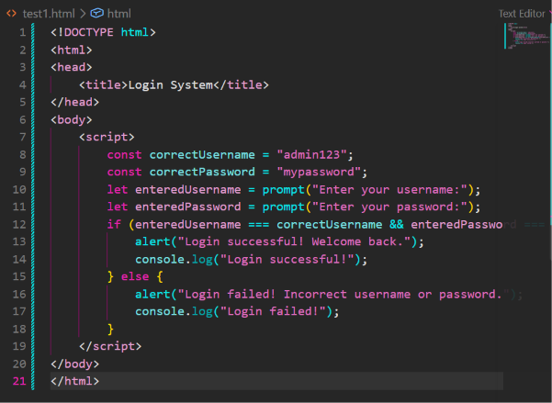
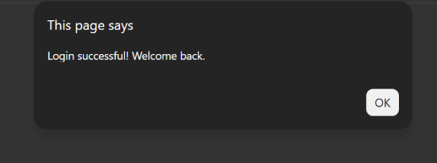
- Analysis: How does the && operator work in your login check? What is "short-circuit evaluation"? How would you use the ! (NOT)
operator to invert a condition? Write a truth table for the &&, ||, and ! operators in JavaScript.

In my login program, I used the && operator to check whether both the username and password are correct. The && operator means AND , so both conditions must be genuine for the login to be successful . If either the username or password is incorrect, the whole condition becomes false . Short circuit evaluation means that JavaScript stops checking a condition when it already knows the final result . For example , in an && condition, if the first condition is false , JavaScript already knows that the pure condition will be false , so it does not need to check the second condition .
Truth Tables
AND (&&)
A | B | Result
True | True | True
True | False | False
False | True | False
False | False | False
OR (||)
A | B | Result
True | True | True
True | False | True
False | True | True
False | False | False
NOT (!)
A | Result
True | False
False | True

